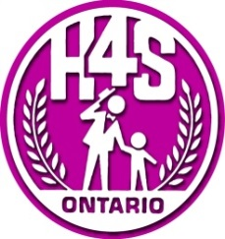
CONSENT TO VIDEOTAPE

I, , authorize Georgian College’s Harmonize for
_{(Print name)}

Speech, Hearing and Language Clinic, and its Faculty Speech-Language Pathologist (SLP)

Clinician, and Communicative Disorders Assistant (CDA) Students (hereinafter, the “clinic”) to

videotape therapy sessions of for the following purpose(s):
_{(Print name of client)}

Please check your preference below:
□ For review by the clinic for the purpose of tracking client progress and providing feedback.

□ For educational purposes to teach theory and techniques of therapy intervention to CDA students and clinic staff.

□ For research purposes carried about by the clinic that involve the study of communication delays/disorders.

I understand that the clinic will not use the recordings outside of the clinic without further written consent by me. I understand that I may withdraw my consent to videotape at any time.

Name of client:
Signature of client/parent/guardian:
Relationship to client:
Witness:
Date:

